White Out

A strange fungus continues to attack the country’s bat population.
Recently, bats with fuzzy white noses have popped up in Indiana, Ohio, Maine, North Carolina, and Kentucky. It’s an ominous development. White-nose syndrome (WNS), a disease that kills hibernating bats, has officially spread into five more states.
The mysterious syndrome was first discovered in the state of New York in 2007. From there, it spread across the United States and Canada. Infected bats can now be found in 16 states and four Canadian provinces.
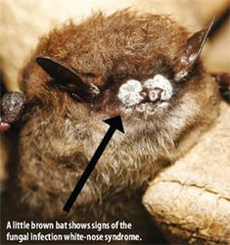
Courtesy Ryan von Linden/NY Department of Environmental Conservation
Scientists have learned a great deal about the disease since its discovery. There’s much they don’t understand, though, including how to stop it. “There’s a lot of work still being done,” says Tom Kunz, a bat expert at Boston University.
Time is of the essence. More than a million and perhaps as many as 2 million bats have died already, Kunz says. “We’ve got a disease that is causing one of the most precipitous declines of bats in American history,” he says.
Skin and Bone
White-nose syndrome is named for the white fungus that typically appears on the muzzles and other body parts of infected bats. Initially, scientists weren’t sure whether the fungus caused the disease. Many suspected it was an opportunistic infection—a secondary infection that gains a foothold in an animal already weakened by another illness.
Researchers haven’t found any other infectious agents in the sickened bats. So most now agree that the fungus is the likely cause of WNS. The fungus is new to science, and researchers have named it Geomyces destructans.
“We still haven’t determined how the bats are actually dying from the fungal infection,” says Jeremy Coleman, the national WNS coordinator for the U.S. Fish and Wildlife Service. One clue: Infected bats seem to run out of fat in the middle of winter. Bats need that fat to nourish themselves until spring. Without it, they die.
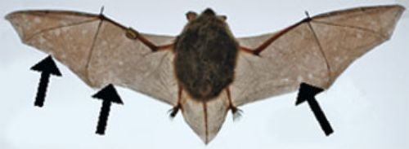
Carol Uphoff Meteyer/USGS
This little brown bat is infected with white-nose syndrome. The arrows point to small patches where its wings have lost their elasticity, coloration, and surface sheen.
Normally, hibernating bats wake briefly once or twice a month, Kunz says. Infected bats arouse from hibernation every four or five days. They then expend valuable calories flying around. That activity probably explains why the bats are so skinny. “Every arousal burns up body fat,” he says.
What makes infected bats wake up so often? Some scientists have proposed an “itch-and-scratch hypothesis.” Just as people scratch their toes like crazy when they have athlete’s foot, a common fungal infection, bats might feel a similar itch when the fungus invades their skin. The uncomfortable sensation could be rousing them from their winter naps.
Then again, the bats might just be thirsty. One of skin’s many jobs is preventing water loss. In bats, healthy wing membranes help maintain a water balance in the body. The fungus damages bat wings, causing small holes and scar tissue to appear in the membranes. Bats could be losing excess water through their injured wings, some scientists propose. The animals might be waking up to find a drink and avoid dehydration (an excessive loss of fluid).
Fungus Among Us
The fungus G. destructans is itself puzzling. Hundreds of other species of Geomyces fungi live in U.S. caves but don’t bother bats at all, says Coleman. And though G. destructans has been found in caves in Europe, bats there appear unaffected by it. Do European bats possess a gene that makes them resistant to infection? Is European G. destructans somehow different from the strain found in the U.S.? “We’re trying to figure out why this fungus is so devastating for [North American] bats,” Coleman says.
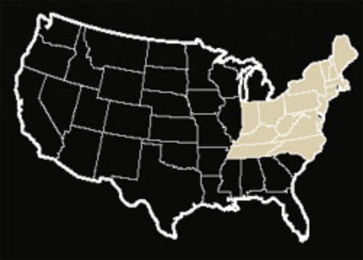
Joe LeMonnier
Discovered in New York state in 2007, white-nose syndrome has since spread to 15 other states and killed more than a million bats.
Meantime, the best hope for North America’s bats seems to be preventing any further spread of WNS. The disease is thought to spread from bat to bat, says Coleman, but researchers haven’t ruled out the possibility that people are spreading it too. The Fish and Wildlife Service has played it safe and closed a number of caves to human visitors. “We’re trying to prevent people from moving the fungus faster than the bats can,” Coleman says.
So far, WNS has been found in nine bat species, including two endangered ones: the Indiana bat and the gray bat. As more states and more species are affected, the impact of WNS could snowball. Bats play an important role in their ecosystems. A bat can eat half its weight in insects every night. A female bat that’s lactating (feeding her pups with milk) can gulp down twice that amount. Insect-eating bats in the U.S. save farmers at least $3 billion a year by swallowing bugs that would otherwise damage crops, according to an analysis in the journal Science. WNS is just beginning to move into the Midwest, the nation’s agricultural heartland. “As it continues to spread, we could see an agricultural impact,” Coleman says.
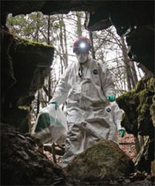
AP Images
Scientist Britta Wood enters an abandoned limestone mine in Rosendale, N.Y., to collect bats infected with white-nose syndrome.
Scientists across the country are hard at work studying the bats, the fungus, and potential ways to manage the disease. “Bats provide a real value,” Kunz says. “This is a massive loss.”
Copyright © 2009 Weekly Reader Corporation. All rights reserved. Used by permission.
Weekly Reader is a registered trademark of Weekly Reader Corporation.

