Cornell Notes
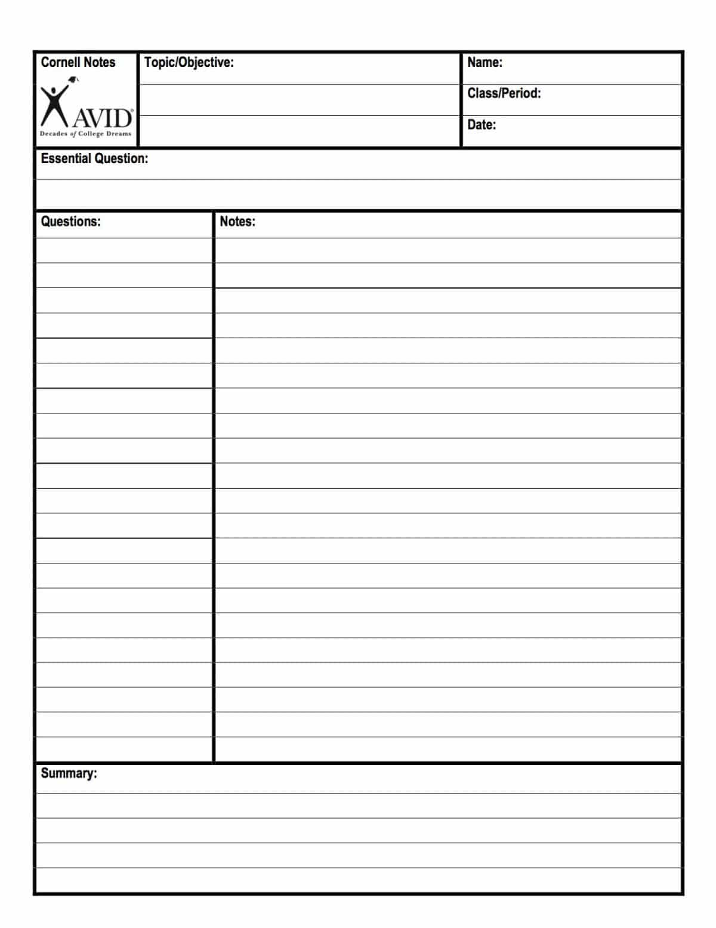
Directions:
- Read/Review the handout on Cornell Notes.
- Take lined paper and fold your paper to resemble the layout of Cornell Note paper. You can get it folded in 2-3 folds.
  - Count up from the bottom 5-7 lines and fold. (Label that bottom section Summary)
  - From the left side of the paper, fold a little past the red, margin line. (Label the margin Questions/Comments/Main ideas)
  - Design the top of the paper to resemble the top of this Cornell Note paper to the left.
- Assignment:
  - Read your assignment for Social Studies and take notes.
  - Go through your notes and show me you reviewed your notes by…
    - Circle key words
    - Highlight or underline main ideas
    - Put a ? by any points of confusion
    - Put a * by possible test question topics within your notes
    - Chunk your notes into main ideas in the margin/left side of the paper where Questions/Comments/Main Ideas
    - Writing test questions on the left where the answer is in the notes on the right.
- See video link we saw in class again if you need a refresher course.

  - Next, summarize your notes into a final summary that makes sense. (About 4-6 sentences max)

- ***Please Note: Keep this paper to refer back to for the weeks to follow.

https://www.youtube.com/watch?v=S8SzXrFQwVc&t=12s
or search Youtube for
“Cornell Notes Intro Video” under the name SRiddle8119

Textbook Note-taking Tips

Be an Active Reader
• Think about the reading.
• Consider the ways that portions of the text relate to the text as a whole; think about how the text relates to ideas from lectures, discussions, and other subjects.
• Generate questions (e.g., about the meaning of new words/terms, about why portions of the text are italicized or underlined, about why emphasized points are important).
• Examine and understand the significance of visuals (e.g., diagrams, graphs, charts, photos, artwork).

Be Aware of Text Organization
• Look for the pattern of elements like chapter/subsection headings, summary points, graphics.
• Know where to find the index and glossary.

Use the Style of the Text to Identify Important Points
• Become familiar with the typefaces, symbols, borders, graphics, colors, and page layouts that highlight main ideas and key terms.

Be Alert to the Writer’s Goal
• Some texts attempt to persuade as well as inform listeners; when applicable, highlight ideas, references, and opinions that seem significant to writer’s point of view.

Take Notes While Reading
• Incorporate chapter headings, key terms, meaningful examples, important graphics into notes.
• Write only the important ideas; make it brief, but clear.
• Paraphrase text to capture meaning and reduce volume.
• Use symbols to highlight significant material and/or areas for further study.
• Use headings, subheadings, and review questions within the text to generate study questions and main ideas for left-hand column of notes.
• Incorporate original questions raised by text into notes.
Review Textbook Notes
• Develop study questions and identify main ideas.
• Fill in details for clarity.
• Identify information that is unclear and/or questions that need to be answered; write and mark questions in the text of notes or at the end where they will be easily found; get answers to the questions from other students, the teacher, or other texts.
• Look up and add definitions of new terminology.
• Add symbols to highlight important ideas.
• Delete irrelevant information.
• Review overall organization of the material; add symbols to make organization clear or rewrite for clarity as needed.
• Incorporate cross references to other texts and notes.
• Write a summary of notes, using significant statements.

