Lesson: Rikki-Tikki-Tavi A. Mendez
Lesson Topic: Snake Eaters: The Mongoose and the Honey Badger
Snake Eaters: The Mongoose and the Honey Badger
Written by Heather Henderson
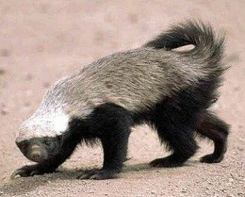
When most people think of fearless animals, the mongoose and honey badger probably aren’t the first creatures that come to mind. Their
small furry bodies make them look more like pets than deadly predators. However, despite their appearance, the mongoose and honey badger
have built a reputation as two of the most courageous predators in the animal kingdom.
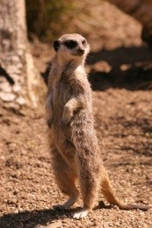

Mongooses
Found mostly in Africa and parts of Asia, mongooses’ slender bodies are usually less than two feet long. They are usually brown or grey in
color and resemble a large ferret or opossum. Mongooses will eat almost anything they can find or catch, including birds, rodents, frogs, insects,
and even the eggs of crocodiles. The mongoose is a zealous hunter, scurrying along turning over rocks and digging with its sharp claws in search
of food. Once it finds a meal, the mongoose typically kills its prey with a swift bite to the back of the neck or head.
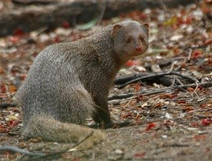
Mongooses get their fearless reputation from enjoying some particularly perilous treats: poisonous animals. Mongooses are notorious for gobbling down scorpions and even poisonous
snakes, most notably the much-feared king cobra. Part of the reason behind the mongooses’
seemingly reckless dietary choices is its immunity to venom. Like poisonous snakes, mongooses
have receptors in their brains that inhibit the absorption of poisonous venom. Despite the
mongoose’s invulnerability to poison, killing a snake is no easy feat. Mongooses can still be harmed
by snakes’ sharp fangs or strangled by their constricting bodies.
The Indian Gray Mongoose, immortalized
in the classic story "Rikki Tikki Tavi," is known for killing cobras.
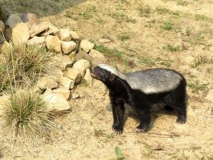

Honey badgers
Battling king cobras and scorpions is hard to beat when it comes to picking the most courageous animal. However, the Guinness Book of World Records has bestowed the title of most fearless animal in the world to another crazy critter: the honey badger. At about 10 inches tall and 2
feet long, honey badgers are similar in size to mongooses, and like mongooses, they’ll eat just about anything.
Unlike mongooses, however, the honey badger is practically indestructible. While the mongoose is impervious to snake venom, the honey
badger’s thick hide makes it impervious to just about everything. In fact, honey badgers get their name from their love of honey, which they eat
straight from the hives of angry swarming bees! The bee’s stingers aren’t able to penetrate the honey badgers hide and are only a minor
distraction for a hungry honey badger. As it turns out, the honey badger’s skin is thick enough to protect it from porcupine quills, most animal
bites, and even a slow-moving arrow or spear. There is no stopping the honey badger!
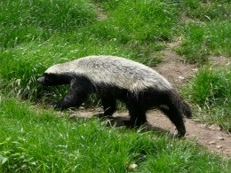
You could almost say that honey badgers, also called "ratels," are shaped like tiny tanks. This would be appropriate as their skin operates as built-in armor!
Like the mongoose, honey badgers kill and eat snakes, including poisonous ones. The honey badger isn’t quite as immune to snake venom
as the mongoose, and often loses consciousness after eating or being bitten by a poisonous snake. However, they usually recover after a
short time and begin looking for their next meal.
Both the mongoose and the honey badger are tougher than meets the eye. Nature has gifted these animals with some incredible
evolutionary adaptions that allow them to continue competing for the title of most fearless animal!
Question 1:
Which animal does the author seem to think is more fearless?
The author shows that neither of the animals are truly fearless.
The author thinks that the mongoose is more fearless because it battles venomous snakes.
The author thinks that the honey badger is more fearless because it also eats honey from active beehives.
The author thinks that both animals are fearless and does not preference one over the other.
Question 2:
What information about mongooses in this article is different from how they are described in the story, "Rikki-Tikki-Tavi"?
The article says that mongooses can be harmed by snakes.
The article says that mongooses are not harmed by snake venom.
The article says that mongooses are known to kill snakes.
The article says that mongooses are difficult to tame.
Question 3:
What is the main idea of this text?
Both mongooses and honey badgers eat snakes.
Both honey badgers and mongooses are fearless creatures that do dangerous things.
Mongooses and honey badgers are relatively small creatures.
Mongooses are immune to snake venom, but honey badgers are not.
Question 4:
What details about honey badgers and mongooses help show that they are fearless?
Check all that are true. their eating habits
their location
their coloring
their popularity as pets
their size
Question 5:
Read the passage below.
Mongooses are notorious for gobbling down scorpions and even poisonous snakes...Part of the reason behind the
mongoose's seemingly reckless dietary choices is its immunity to venom... Despite the mongoose's invulnerability to
poison, killing a snake is no easy feat.
What does the word invulnerability mean in this passage?
resistance
disgust
attraction
sensitivity
Question 6:
Read the passages below.

Passage 1
Like the mongoose, honey badgers kill and eat snakes, including poisonous ones. The honey badger isn't quite as immune to snake venom as the
mongoose, and often loses consciousness after eating or being bitten by a poisonous snake. However, they usually recover after a short time and begin
looking for their next meal.

Passage 2
Every snake bite is different, and there are many different types of venom. Each type of snake venom affects the body differently, requiring its own
specialized treatment. The venom in most snakes is a combination of three main toxins: cytotoxins, neurotoxins, and hemotoxins.
What topic is addressed by both passages?
cytotoxic venom, the mildest form of snake venom
animals that kill and eat snakes
differing reactions to snake bites
treatments for snake venom
Question 7:
Read the passage below.
When most people think of fearless animals, the mongoose and honey badger probably aren’t the first creatures that come to
mind. Their small, furry bodies make them look more like pets than deadly predators.
How does this passage contribute to the main idea of the article?
It shows that the personality of the mongoose and honey badger is inconsistent with their appearance.
It shows that honey badgers and mongooses are not really fearless as some may think.
It shows that there are other creatures that are more deadly than the mongoose and honey badger.
It shows that mongooses and honey badgers make loveable, cuddly pets.
Question 8:
What statement challenges the author's claim that honey badgers are "fearless" because they eat honey from active hives?
You should only be considered fearless if you do something even though it will hurt you.
You should be considered reckless, not fearless, if you do something that can hurt you. You should only be considered fearless if you do something that most others would not do. none of the above
Question 9:
Based on this article, how would a more factually accurate version of the story "Rikki Tikki Tavi" most likely be different from the
one you read?
Rikki would not be friends with Darzee and his wife.
Rikki would not fight Nag and Nagaina.
Rikki would bite Teddy and his family.
Rikki would die from Nag's venom.
all of the above

